Please complete the following examples on Tinkercad:

1. [potenioLEDs](https://www.tinkercad.com/things/bHize6dhmeP?sharecode=RFAhDR5s5c-FGv8iam1U-pq7xnRovr-DimkXeZ64mLE):  A potentiometer is used as a voltage divider. The adjustable output from the potentiometer is connected to Arduino Uno pin A0. Read the analog measurement at pin A0 and convert it into voltage. Use the four LEDs, which are connected to GPIO pins 2, 3, 4, and 5, as an indicator for the analog voltage level. Use the thresholds shown in the following table.

|  |  |  |  |  |
| --- | --- | --- | --- | --- |
| Analog Measurement | PIN 5 | PIN 4 | PIN 3 | PIN 2 |
| 0 to 0.1 V | 0 | 0 | 0 | 0 |
| 0.1V to 1V | 0 | 0 | 0 | 1 |
| 1V to 2V | 0 | 0 | 1 | 1 |
| 2V to 3V | 0 | 1 | 1 | 1 |
| > 3V | 1 | 1 | 1 | 1 |

1. [temp_serial](https://www.tinkercad.com/things/8KZaxiPgAvW?sharecode=bPr3kMheUwSwkv9oEiKX0iHkARAwPzZi4m_wNfHCN2g): TMP36 is a 3-pin temperature sensor IC. It outputs an analog voltage proportional to the ambient temperature. The output pin is connected to Arduino Uno pin A0. Its output reads 0.75 V @ 25°C according to its [datasheet](https://cdn-learn.adafruit.com/assets/assets/000/010/131/original/TMP35_36_37.pdf). You need to write a mapping equation that converts the number 0.75 V to 25°C.

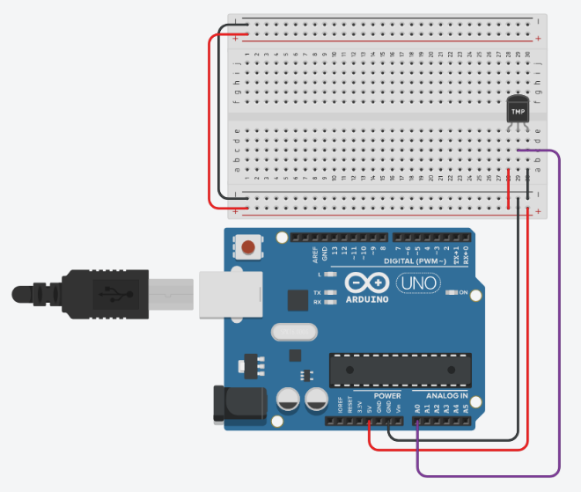

1. [serialLEDs](https://www.tinkercad.com/things/3ODXixQoARR?sharecode=5WSiAhQgv_qWiVeDqb6c876DUIp2MzrehZFa7e5R3Ao): Use the serial monitor to send a single character (0, 1, 2, .., 9, A/a, B/b, .., or F/f) as a HEX value representing the values 0 to 15. Receive this character on the Microcontroller. Use the four LEDs, which are connected to GPIO pins 2, 3, 4, and 5, to display the value of the received character. You should print a statement on the serial monitor telling the user that they sent an out-of-range value if the received character is not among the base-16 HEX values, i.e., 0 to F. You can accept both upper- and lower-case letters. Try to use if else and switch case conditional tests.

